

**Lab Manual- Creating a zonal cluster with Google Kubernetes Engine (GKE)**

**Prepared for**:

**Date:** 18th May 2024

**Prepared by:**

Document Name: Lab Manual **Document Number** GCPLabn009

**Contributor:**

Contents

1. Objective 3

1. Single-zone versus multi-zonal 3

2. Create a GKE Zonal Cluster 3

3. Connect GKE Cluster with Kubectl 10

1. In the Clsuter console click : extreme right and click connect 10

2. Click Run in Cloud Shell 10

3. Click following command in Cloud Shell 10

4. Deploy and expose an application 11

5. Delete Deployment and Service 12

# Objective

This Lab shows you how to create a Standard [zonal cluster](https://cloud.google.com/kubernetes-engine/docs/concepts/types-of-clusters#zonal_clusters) with the default features enabled in Google Kubernetes Engine (GKE). Zonal clusters have a single control plane in a single [zone](https://cloud.google.com/compute/docs/regions-zones). Depending on your availability requirements, you can choose to distribute your nodes for your zonal cluster in a single zone or in multiple zones.

**Important:** **Use regional clusters to run your production workloads as they offer higher availability than zonal clusters.**

## Single-zone versus multi-zonal

A **single-zone** cluster has a single control plane running in one zone. This control plane manages workloads on nodes running in the same zone. If you run a workload in a single zone, this workload is unavailable in the event of a zonal outage.

A **multi-zonal** cluster's nodes run in multiple zones, but it has only a single replica of the control plane. If you run a workload in multiple zones and there is a zonal outage, the workload is disrupted in that zone but remains available in other zones.

If you need higher availability for the control plane, consider creating a [regional cluster](https://cloud.google.com/kubernetes-engine/docs/concepts/types-of-clusters#regional_clusters) instead. In a regional cluster, the control plane is replicated across multiple zones in a region.

# Create a GKE Zonal Cluster

To create a zonal cluster with the Google Cloud console, perform the following tasks:

1. Go to the **Google Kubernetes Engine** page in the Google Cloud console.

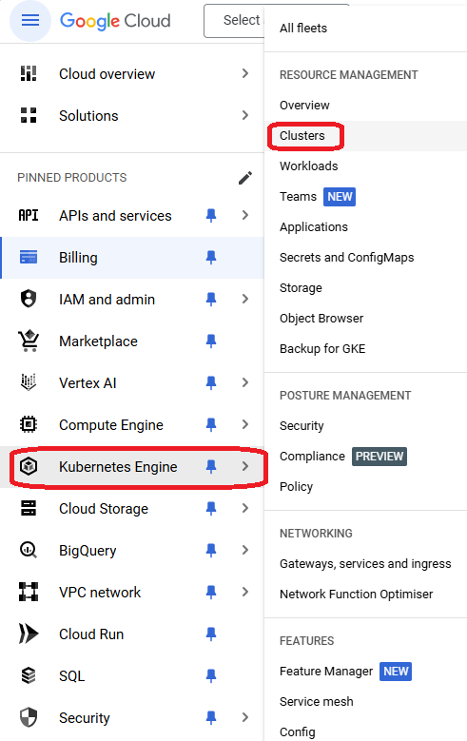

1. Click add_box **Create**.

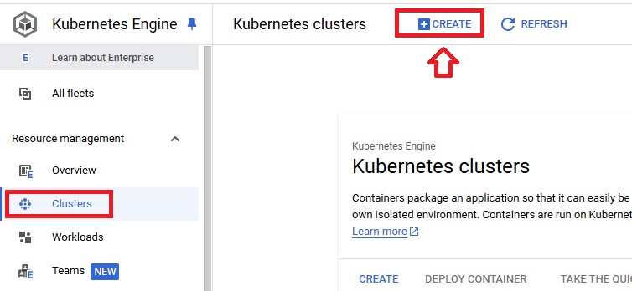

1. Click Switch to **Standard Cluster**

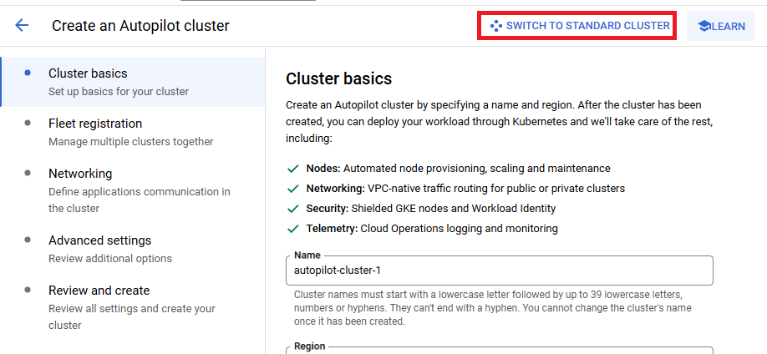

1. Click **Switch to Standard Cluster**

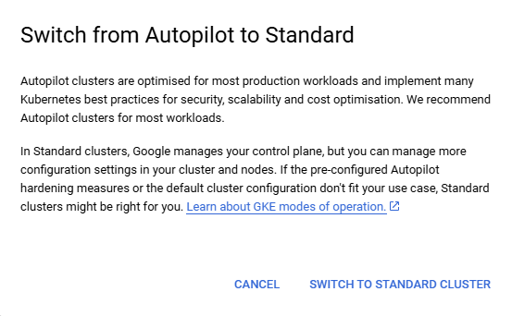

1. In the **Cluster basics** section, complete the following:

* Enter the **Name** for your cluster.
* For the **Location type**, select **Zonal**, and then select the [zone](https://cloud.google.com/compute/docs/regions-zones#available) for your cluster.

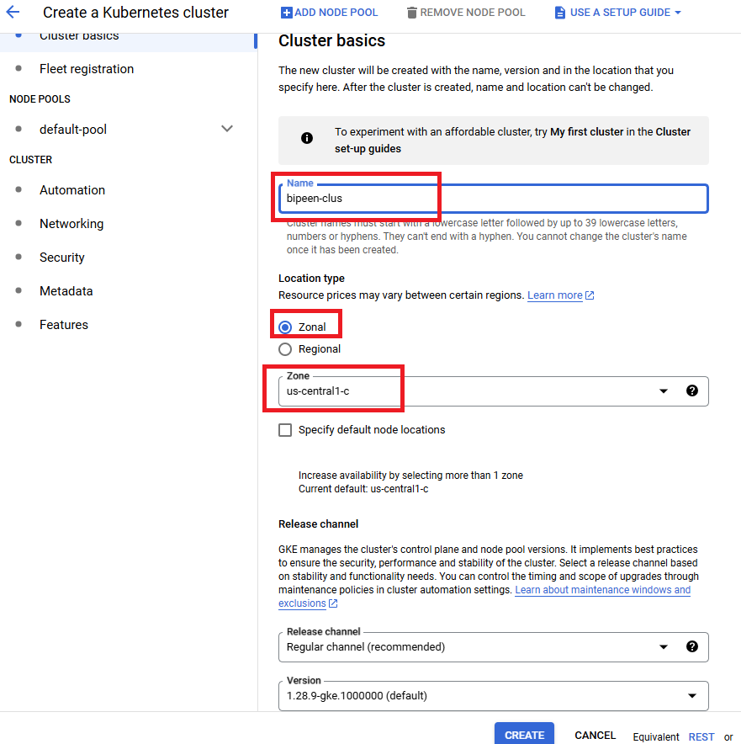

1. Leave all option default ( Optional (available with [GKE Enterprise](https://cloud.google.com/kubernetes-engine/enterprise/docs/concepts/gke-editions)): If you want to register your new cluster to a [fleet](https://cloud.google.com/kubernetes-engine/fleet-management/docs), go to the **Fleet registration** section, and follow the Google Cloud console instructions for [Create and register a new cluster](https://cloud.google.com/kubernetes-engine/fleet-management/docs/register/gke#console) to complete your cluster registration.

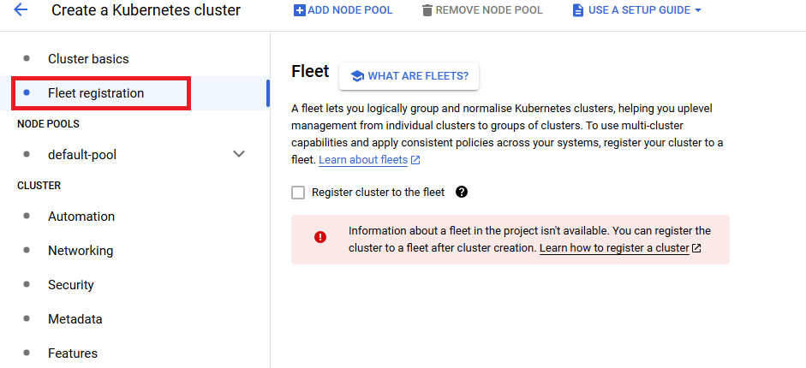

1. In The Node Pool, Select **Default pool** from left
   1. **Number of Nodes:** 1

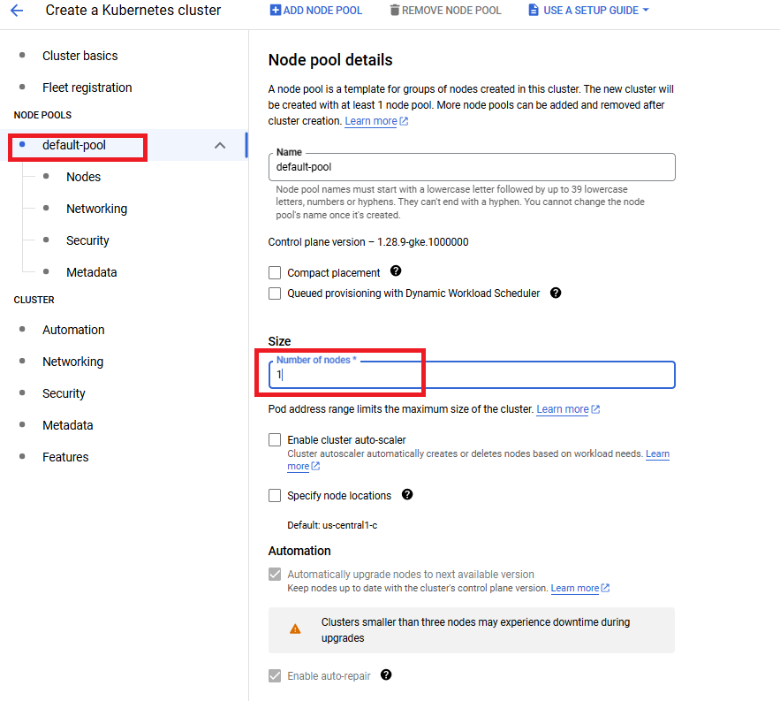

1. In The Node Pool, Select **Nodes** from left

**Allowed Images:** - Container-optimised OS with containerd

**VM Instance Type:** n1-standard-1

**Disk Size:** 10 GiB

**Disk Types** - Balanced persistent disk

* 1. N1 as

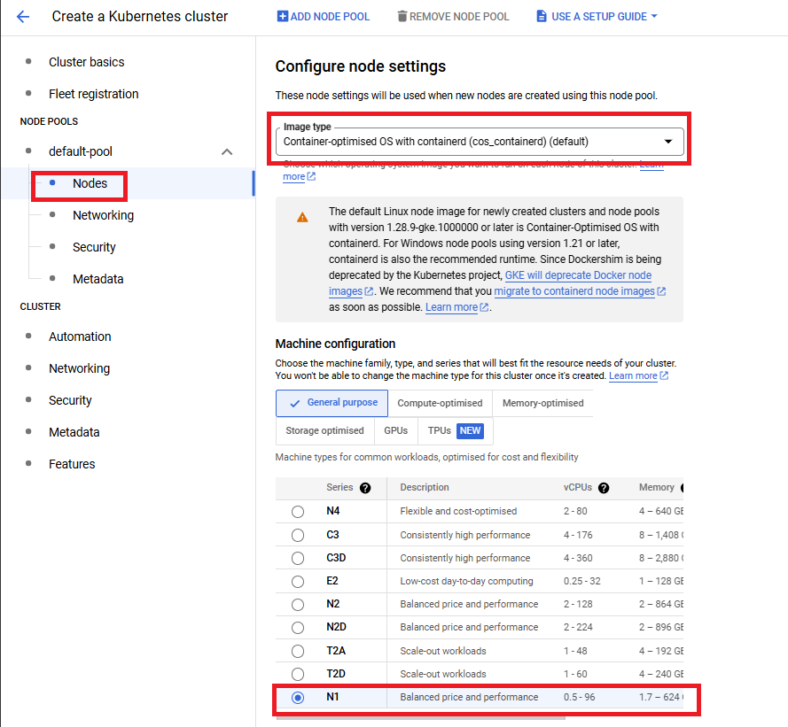

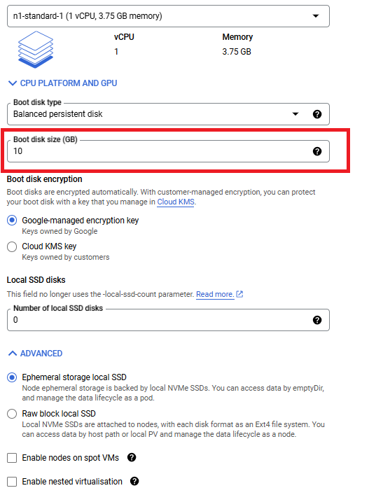

1. Click Create Button to Create the cluster
2. Once Installation Complete you see the Status Green

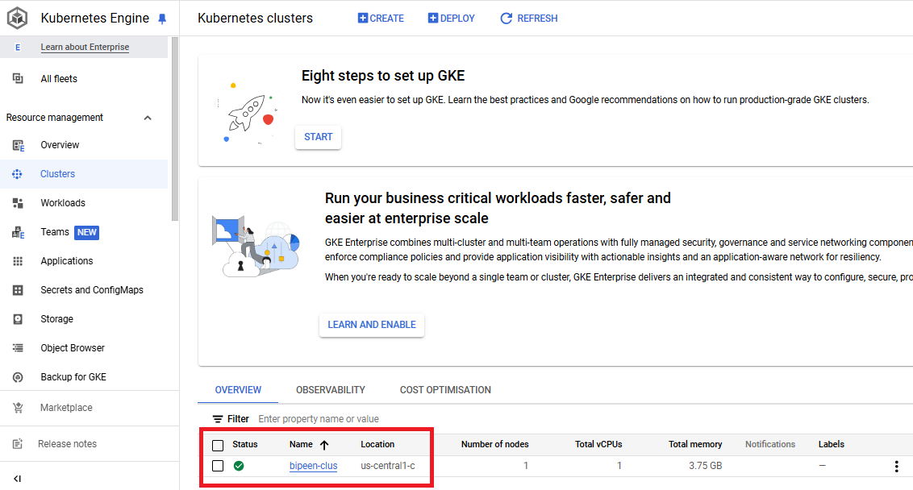

# Connect GKE Cluster with Kubectl

## In the Clsuter console click : extreme right and click connect

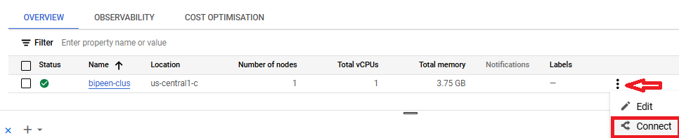

## Click Run in Cloud Shell

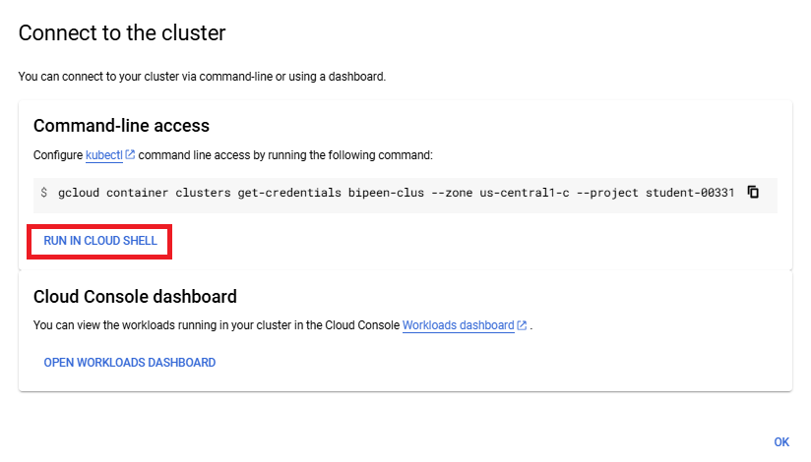



## Click following command in Cloud Shell

**kubectl get nodes**

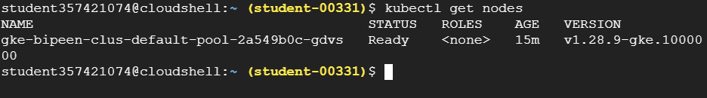

# Deploy and expose an application

**kubectl create deployment --image tutum/hello-world webserver**

**kubectl get pods**

**kubectl scale deployment --replicas 3 webserver**

**kubectl get pods**

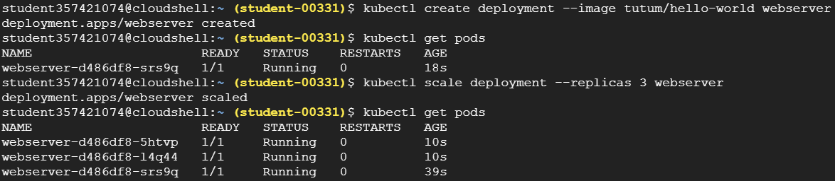

**kubectl expose deployment webserver --name webserver-lb --type LoadBalancer --port 80 --target-port 80**



Run below command after 5 min

**Kubectl get service**

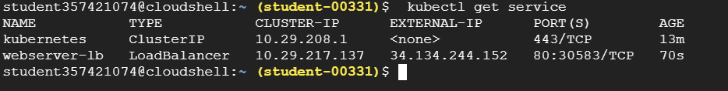

Copy the **public IP** ( External-IP) and Paste in your device browser

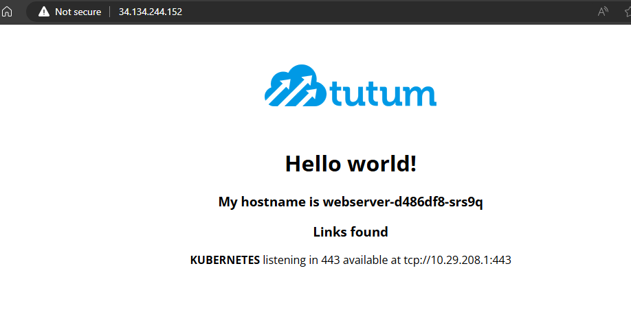

# Delete Deployment and Service

**kubectl delete deployment webserver**



**kubectl delete service webserver-lb**

